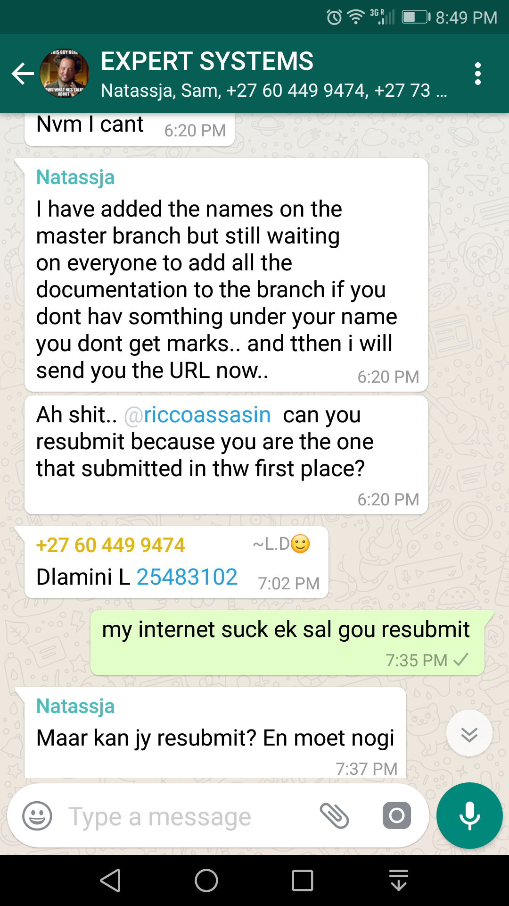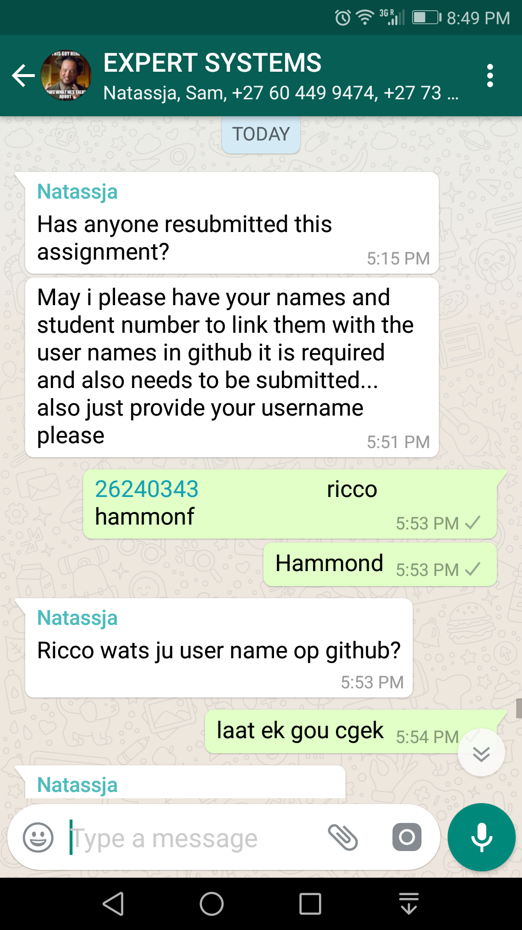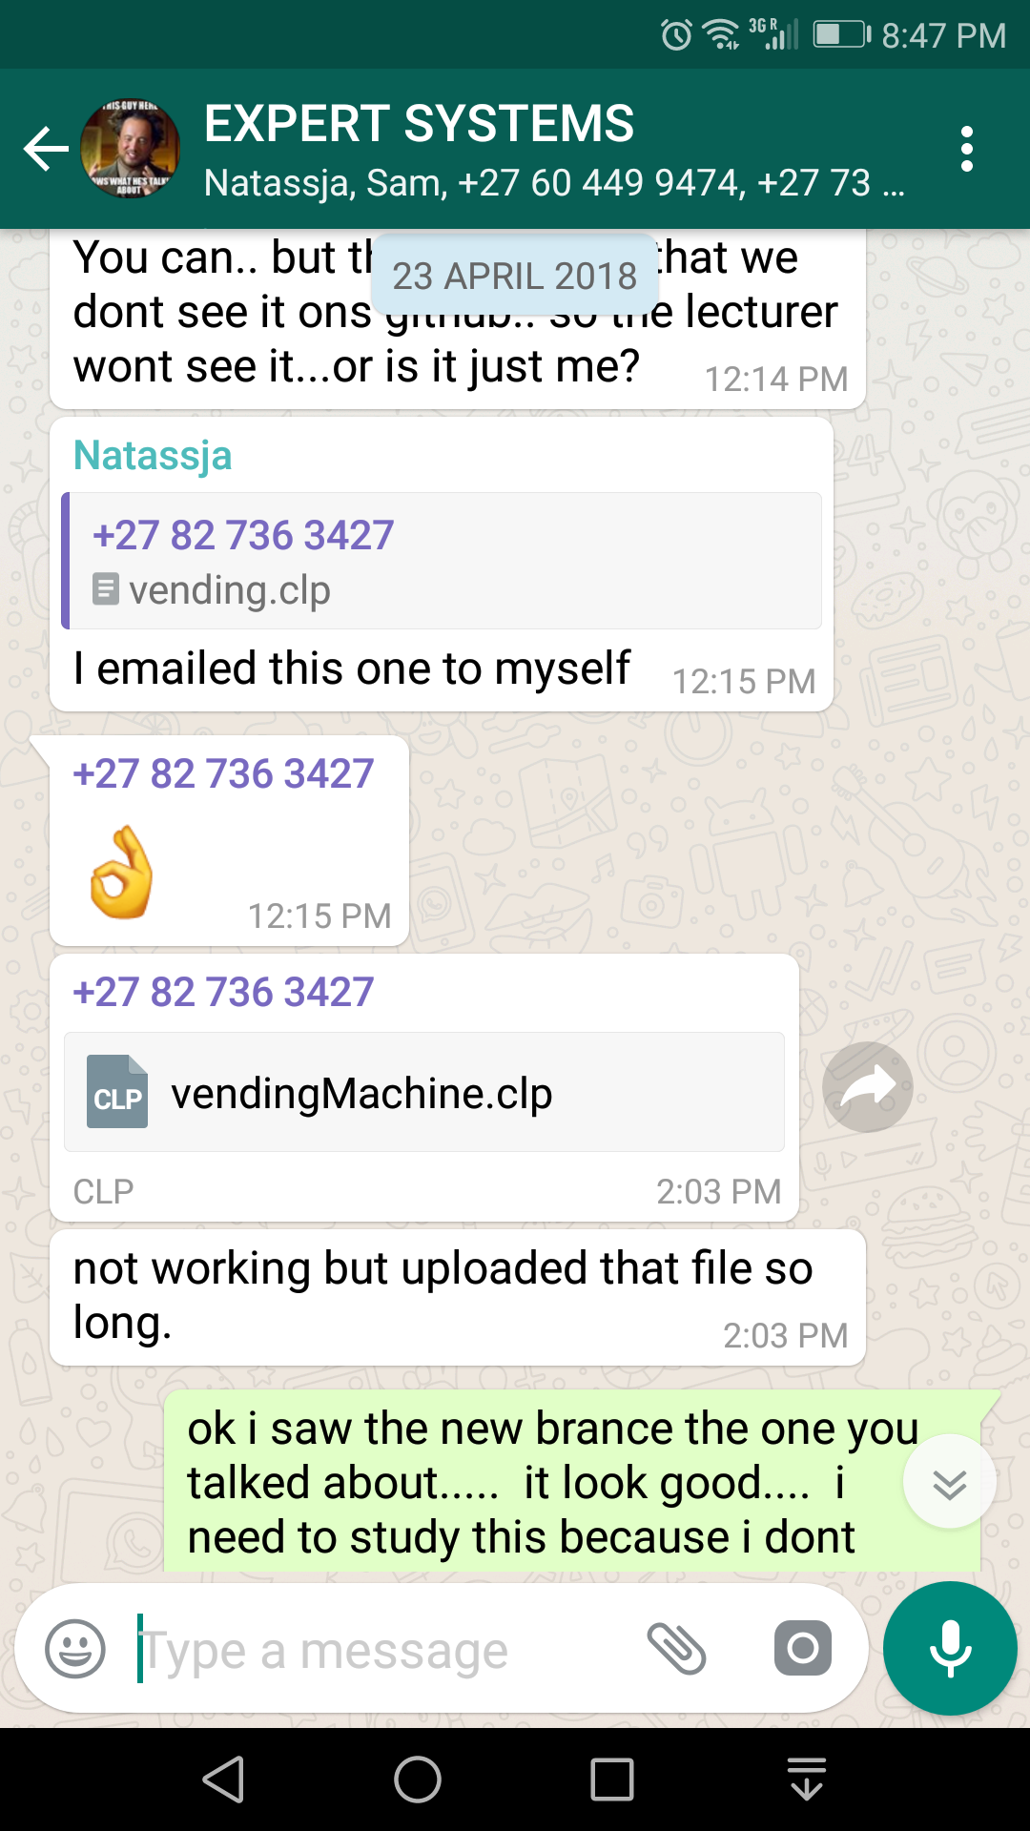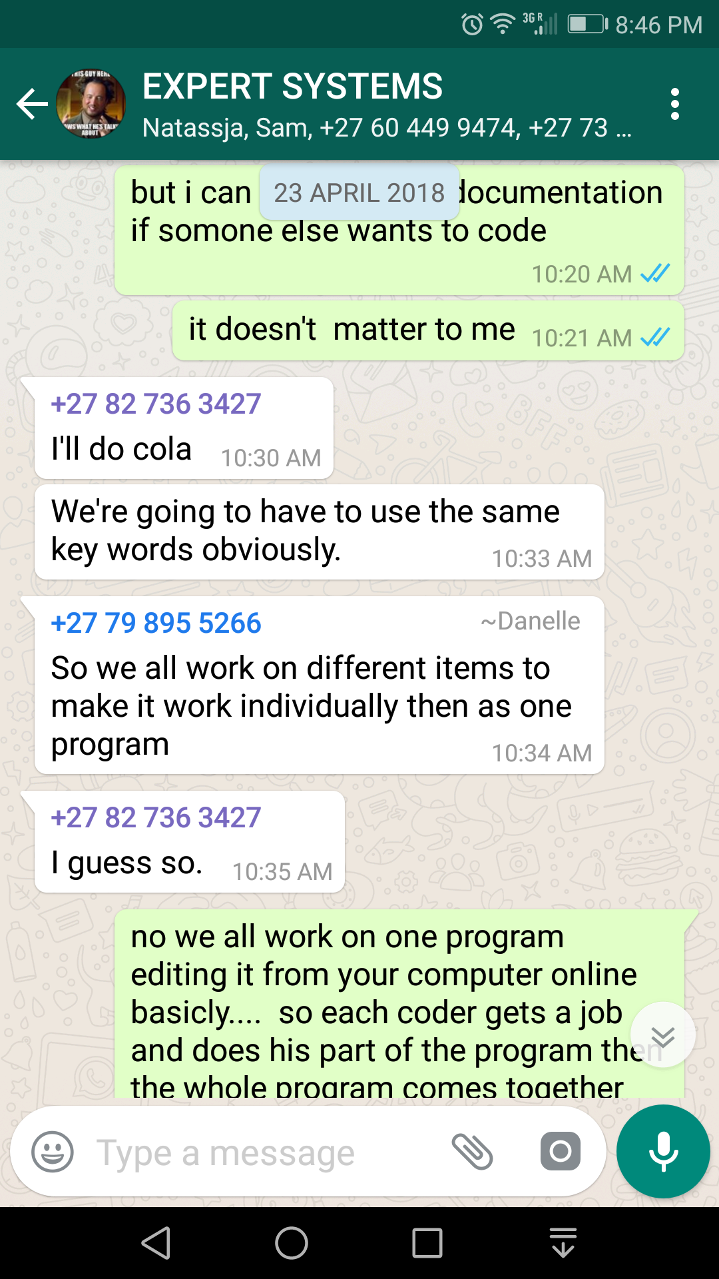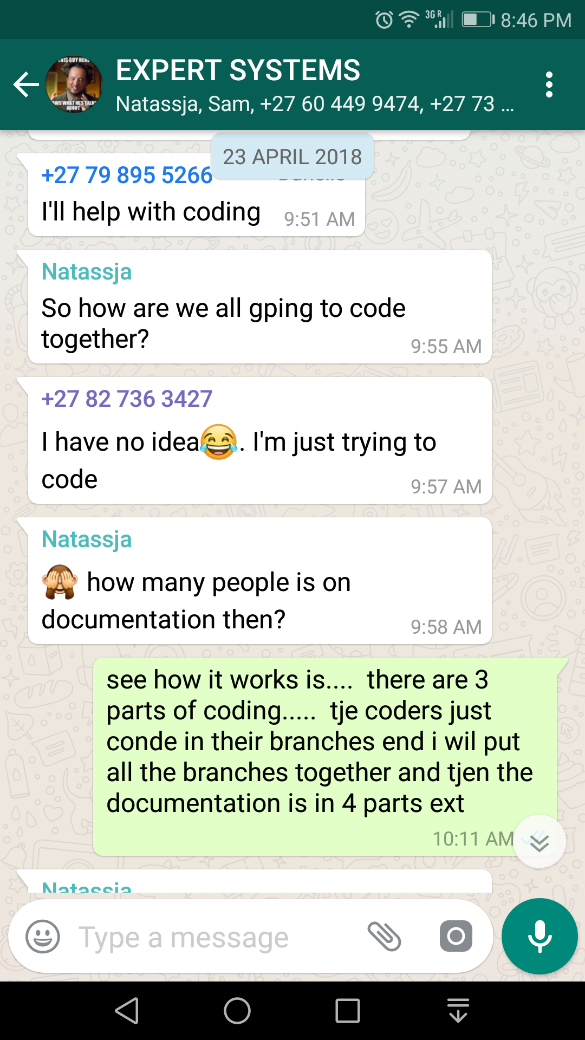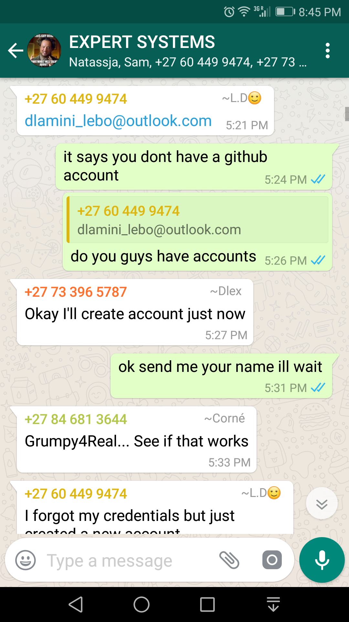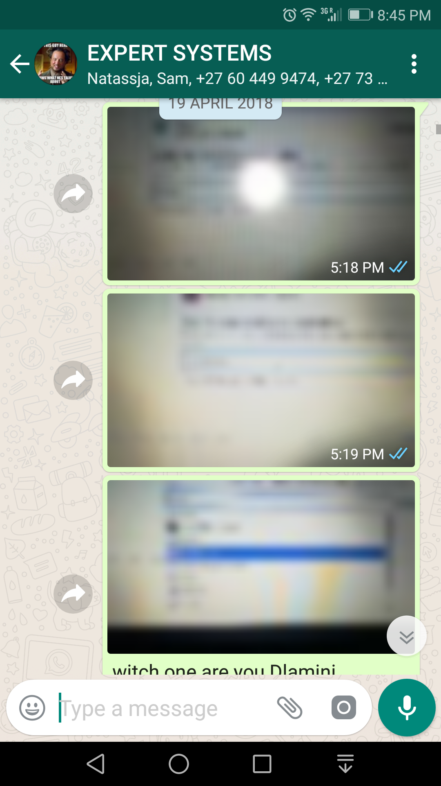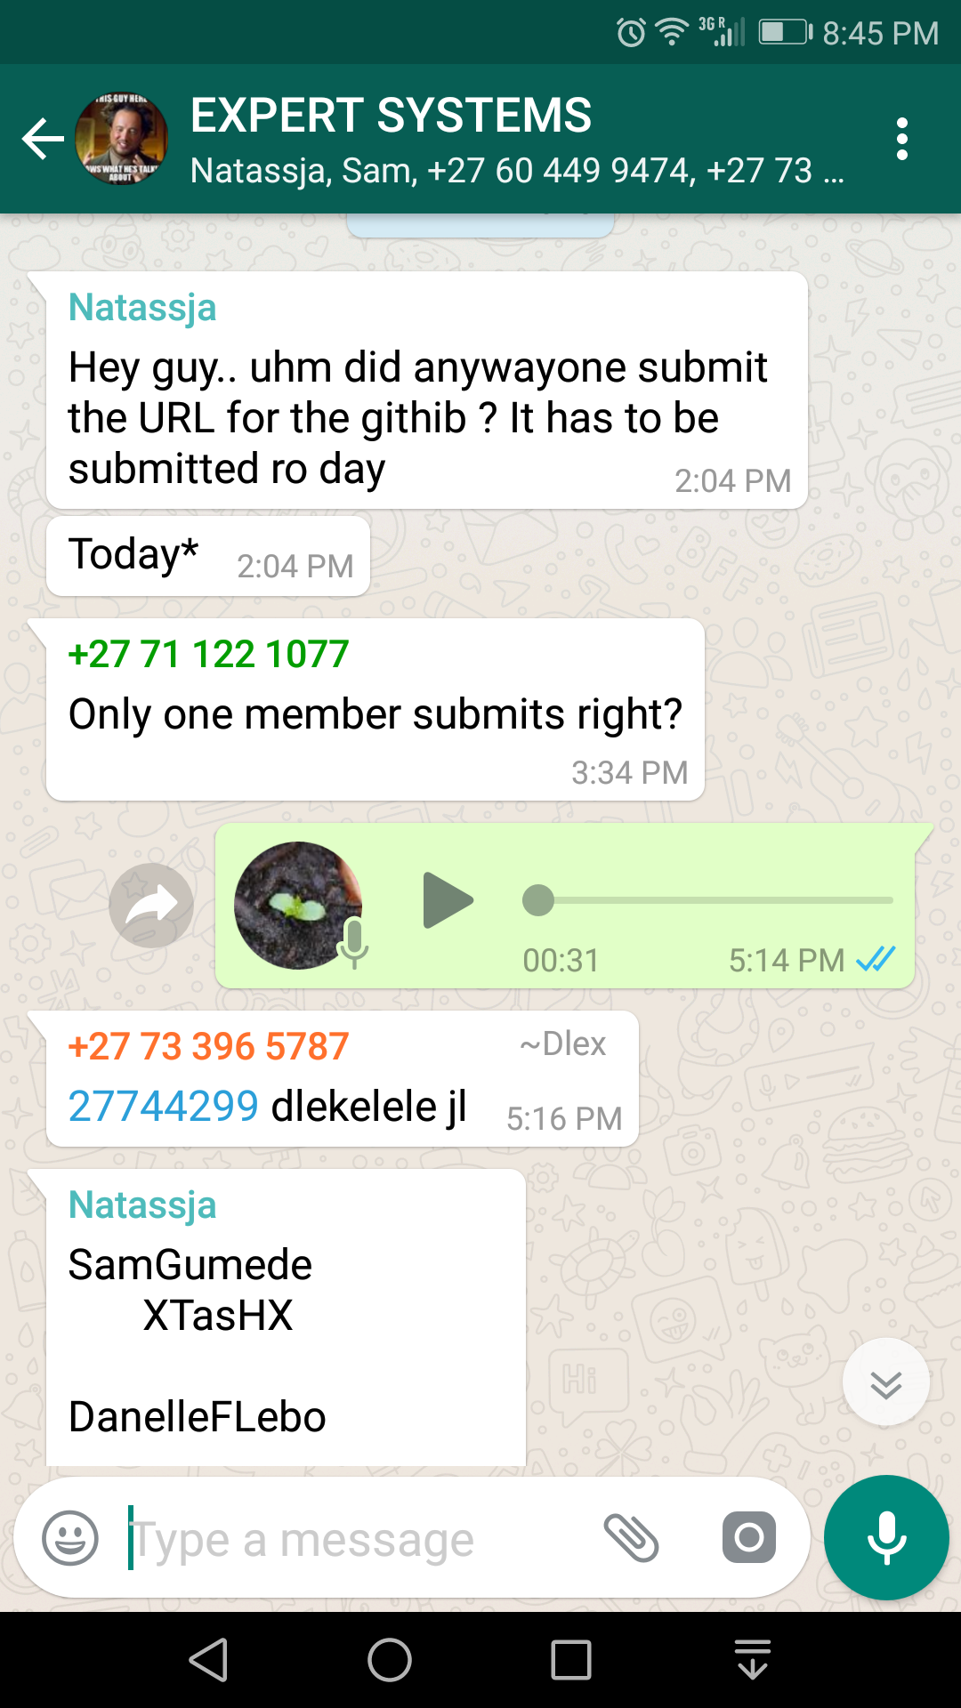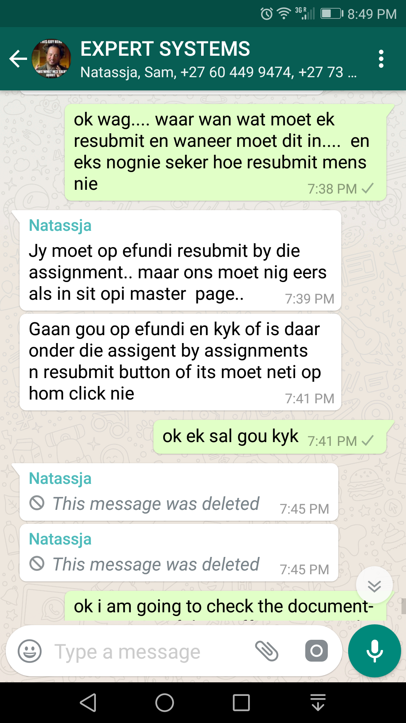

As you can see in the screenshots here we have decided the following

Natassja: she was responsible for the programming part of one of the items that we can buy with the coins.

Dannelle FLebo: was responsible for a part of the documentation

Dlamini: was responsible for a part of the documentation

Ricco : he was responsible for revising the work and a part of the documentation and programming

Megan : she was responsible for a part of the programming

As you can see we all played a part in creating this project together.